Nama : Rismawati Laia

NPM : 18110456

1. Koding program welcome.blade.php
2. <!DOCTYPE html>
3. <html lang="{{ str_replace('_', '-', app()->getLocale()) }}">
4. <head>
5. <meta charset="utf-8">
6. <meta name="viewport" content="width=device-width, initial-scale=1">
7. <title>Laravel</title>
8. <!-- Fonts -->
9. <link href="https://fonts.googleapis.com/css?family=Nunito:200,600" rel="stylesheet">
10. <!-- Styles -->
11. <style>
12. html, body {
13. background-color: #fff;
14. color: #636b6f;
15. font-family: 'Nunito', sans-serif;
16. font-weight: 200;
17. height: 100vh;
18. margin: 0;
19. }
20. .full-height {
21. height: 100vh;
22. }
23. .flex-center {
24. align-items: center;
25. display: flex;
26. justify-content: center;
27. }
28. .position-ref {
29. position: relative;
30. }
31. .top-right {
32. position: absolute;
33. right: 10px;
34. top: 18px;
35. }
36. .content {
37. text-align: center;
38. }
39. .title {
40. font-size: 84px;
41. }
42. .links > a {
43. color: #636b6f;
44. padding: 0 25px;
45. font-size: 13px;
46. font-weight: 600;
47. letter-spacing: .1rem;
48. text-decoration: none;
49. text-transform: uppercase;
50. }
51. .m-b-md {
52. margin-bottom: 30px;
53. }
54. </style>
55. </head>
56. <body>
57. <div class="flex-center position-ref full-height">
58. @if (Route::has('login'))
59. <div class="top-right links">
60. @auth
61. <a href="{{ url('/home') }}">Home</a>
62. @else
63. <a href="{{ route('login') }}">Login</a>
64. @if (Route::has('register'))
65. <a href="{{ route('register') }}">Register</a>
66. @endif
67. @endauth
68. </div>
69. @endif
70. <div class="content">
71. <div class="title m-b-md">
72. Kristin Laia
73. </div>
74. <div class="links">
75. <a href="/">Home</a>
76. <a href="/data">Biodata</a>
77. </div>
78. </div>
79. </div>
80. </body>
81. </html>

2. Koding program index.blade.php

<!DOCTYPE html>

<html lang="{{ str_replace('_', '-', app()->getLocale()) }}">

    <head>

        <meta charset="utf-8">

        <meta name="viewport" content="width=device-width, initial-scale=1">

        <title>CRUD Laravel</title>

        <!-- Fonts -->

        <link href="https://fonts.googleapis.com/css?family=Nunito:200,600" rel="stylesheet">

        <!-- Styles -->

        <style>

            html, body {

                background-color: #7FFFD4;

                color: #636b6f;

                font-family: 'Nunito', sans-serif;

                font-weight: 200;

                height: 100vh;

                margin: 0;

            }

            .full-height {

                height: 100vh;

            }

            .flex-center {

                align-items: center;

                display: flex;

                justify-content: center;

            }

            .position-ref {

                position: relative;

            }

            .top-right {

                position: absolute;

                right: 10px;

                top: 18px;

            }

            .content {

                text-align: center;

                color:  #000000 ;

            }

            .title {

                font-size: 84px;

            }

            .links > a {

                color: #636b6f;

                padding: 0 25px;

                font-size: 13px;

                font-weight: 600;

                letter-spacing: .1rem;

                text-decoration: none;

                text-transform: uppercase;

            }

            .m-b-md {

                margin-bottom: 30px;

            }

        </style>

    </head>

    <body>

        <div class="flex-center position-ref full-height">

            @if (Route::has('login'))

                <div class="top-right links">

                    @auth

                        <a href="{{ url('/home') }}">Home</a>

                    @else

                        <a href="{{ route('login') }}">Login</a>

                        @if (Route::has('register'))

                            <a href="{{ route('register') }}">Register</a>

                        @endif

                    @endauth

                </div>

            @endif

            <div class="content">

            <h2 align="center">Tugas UTS</h2>

    <h3 align="center">Biodata</h3>

    <a align="center" href="/data/tambah"> + Tambah Biodata Baru</a>

    <br/>

    <br/>

    <table align="center" border="1">

        <tr>

            <th>NPM</th>

            <th>Nama</th>

            <th>Jurusan</th>

            <th>Prodi</th>

            <th>Alamat</th>

            <th>Opsi</th>

        </tr>

        @foreach($data as $p)

        <tr>

            <td>{{ $p->npm }}</td>

            <td>{{ $p->nama }}</td>

            <td>{{ $p->jurusan }}</td>

            <td>{{ $p->prodi }}</td>

            <td>{{ $p->alamat }}</td>

            <td>

                <a href="/data/edit/{{ $p->npm }}">Edit</a>

                |

                <a href="/data/hapus/{{ $p->npm }}">Hapus</a>

            </td>

        </tr>

        @endforeach

    </table>

    <br/>

    <br/>

    <div class="links">

                    <a href="/">Home</a>

                    <a href="/data">Biodata</a>

                    </div>

            </div>

        </div>

    </body>

</html>

3. koding program tambah.blade.php

<!DOCTYPE html>

<html lang="{{ str_replace('_', '-', app()->getLocale()) }}">

    <head>

        <meta charset="utf-8">

        <meta name="viewport" content="width=device-width, initial-scale=1">

        <title>CRUD Laravel</title>

        <!-- Fonts -->

        <link href="https://fonts.googleapis.com/css?family=Nunito:200,600" rel="stylesheet">

        <!-- Styles -->

        <style>

            html, body {

                background-color: #7FFFD4;

                color: #636b6f;

                font-family: 'Nunito', sans-serif;

                font-weight: 200;

                height: 100vh;

                margin: 0;

            }

            .full-height {

                height: 100vh;

            }

            .flex-center {

                align-items: center;

                display: flex;

                justify-content: center;

            }

            .position-ref {

                position: relative;

            }

            .top-right {

                position: absolute;

                right: 10px;

                top: 18px;

            }

            .content {

                text-align: center;

                color :#000

            }

            .title {

                font-size: 84px;

            }

            .links > a {

                color: #636b6f;

                padding: 0 25px;

                font-size: 13px;

                font-weight: 600;

                letter-spacing: .1rem;

                text-decoration: none;

                text-transform: uppercase;

            }

            .m-b-md {

                margin-bottom: 30px;

            }

        </style>

    </head>

    <body>

        <div class="flex-center position-ref full-height">

            @if (Route::has('login'))

                <div class="top-right links">

                    @auth

                        <a href="{{ url('/home') }}">Home</a>

                    @else

                        <a href="{{ route('login') }}">Login</a>

                        @if (Route::has('register'))

                            <a href="{{ route('register') }}">Register</a>

                        @endif

                    @endauth

                </div>

            @endif

            <div class="content">

            <h2 align="center">Tugas UTS</h2>

    <h3 align="center">Biodata</h3>

    <a href="/data"> Kembali</a>

    <br/>

    <br/>

    <form action="/data/store" method="post">

        {{ csrf_field() }}

        <table  border="0.5">

        <tr><td align=left>N  P  M: <input type="text" name="npm" required="required"> </td></tr>

        <tr><td align=left>N a m a: <input type="text" name="nama" required="required"> </td></tr>

        <tr><td align=left>Jurusan: <input type="text" name="jurusan" required="required"> </td></tr>

        <tr><td align=left>Prodi  : <input type="text" name="prodi" required="required"> </td></tr>

        <tr><td align=left>Alamat : <textarea name="alamat" required="required"></textarea> </td></tr>

        </table>

        <br/>

        <input type="submit" value="Simpan Data">

    </form>

            </div>

        </div>

    </body>

</html>

4.koding program edit.blade.php

<!DOCTYPE html>

<html lang="{{ str_replace('_', '-', app()->getLocale()) }}">

    <head>

        <meta charset="utf-8">

        <meta name="viewport" content="width=device-width, initial-scale=1">

        <title>CRUD Laravel</title>

        <!-- Fonts -->

        <link href="https://fonts.googleapis.com/css?family=Nunito:200,600" rel="stylesheet">

        <!-- Styles -->

        <style>

            html, body {

                background-color: #7FFFD4;

                color: #636b6f;

                font-family: 'Nunito', sans-serif;

                font-weight: 200;

                height: 100vh;

                margin: 0;

            }

            .full-height {

                height: 100vh;

            }

            .flex-center {

                align-items: center;

                display: flex;

                justify-content: center;

            }

            .position-ref {

                position: relative;

            }

            .top-right {

                position: absolute;

                right: 10px;

                top: 18px;

            }

            .content {

                text-align: center;

                color :#000

            }

            .title {

                font-size: 84px;

            }

            .links > a {

                color: #636b6f;

                padding: 0 25px;

                font-size: 13px;

                font-weight: 600;

                letter-spacing: .1rem;

                text-decoration: none;

                text-transform: uppercase;

            }

            .m-b-md {

                margin-bottom: 30px;

            }

        </style>

    </head>

    <body>

        <div class="flex-center position-ref full-height">

            @if (Route::has('login'))

                <div class="top-right links">

                    @auth

                        <a href="{{ url('/home') }}">Home</a>

                    @else

                        <a href="{{ route('login') }}">Login</a>

                        @if (Route::has('register'))

                            <a href="{{ route('register') }}">Register</a>

                        @endif

                    @endauth

                </div>

            @endif

            <div class="content">

            <h2 align="center">Tugas UTS</h2>

    <h3 align="center">Edit Biodata</h3>

    <a href="/data"> Kembali</a>

    <br/>

    <br/>

    @foreach($data as $p)

    <form action="/data/update" method="post">

        {{ csrf_field() }}

        <input type="hidden" name="npm" value="{{ $p->npm }}"> <br/>

        Nama    :<input type="text" required="required" name="nama" value="{{ $p->nama }}"> <br/>

        Jurusan : <input type="text" required="required" name="jurusan" value="{{ $p->jurusan }}"> <br/>

        Prodi   : <input type="text" required="required" name="prodi" value="{{ $p->prodi }}"> <br/>

        Alamat  : <textarea required="required" name="alamat">{{ $p->alamat }}</textarea> <br/>

        <input type="submit" value="Simpan Data">

    </form>

    @endforeach

            </div>

        </div>

    </body>

</html>

</body>

</html>

5. koding program route/web.php

<?php

use Illuminate\Support\Facades\Route;

/*

|--------------------------------------------------------------------------

| Web Routes

|--------------------------------------------------------------------------

|

| Here is where you can register web routes for your application. These

| routes are loaded by the RouteServiceProvider within a group which

| contains the "web" middleware group. Now create something great!

|

*/

Route::get('/', function () {

    return view('welcome');

});

Route::get('/data','BiodataController@index');

Route::get('/data/tambah','BiodataController@tambah');

Route::post('/data/store','BiodataController@store');

Route::get('/data/edit/{id}','BiodataController@edit');

Route::post('/data/update','BiodataController@update');

Route::get('/data/hapus/{id}','BiodataController@hapus');

6. koding program biodatacontroller.php

<?php

namespace App\Http\Controllers;

use Illuminate\Http\Request;

use Illuminate\Support\Facades\DB;

class BiodataController extends Controller

{

    public function index()

    {

        // mengambil data dari table pegawai

        $data = DB::table('data')->get();

        // mengirim data pegawai ke view index

        return view('index',['data' => $data]);

    }

// method untuk menampilkan view form tambah pegawai

    public function tambah()

    {

        // memanggil view tambah

        return view('tambah');

    }

    // method untuk insert data ke table pegawai

public function store(Request $request)

    {

    // insert data ke table pegawai

    DB::table('data')->insert([

        'npm' => $request->npm,

        'nama' => $request->nama,

        'jurusan' => $request->jurusan,

        'prodi' => $request->prodi,

        'alamat' => $request->alamat

    ]);

    // alihkan halaman ke halaman pegawai

    return redirect('/data');

    }

    // method untuk edit data pegawai

    public function edit($npm)

    {

    // mengambil data pegawai berdasarkan id yang dipilih

    $data = DB::table('data')->where('npm',$npm)->get();

    // passing data pegawai yang didapat ke view edit.blade.php

    return view('edit',['data' => $data]);

    }

    // update data pegawai

public function update(Request $request)

    {

    // update data pegawai

    DB::table('data')->where('npm',$request->npm)->update([

        'nama' => $request->nama,

        'jurusan' => $request->jurusan,

        'prodi' => $request->prodi,

        'alamat' => $request->alamat

    ]);

    // alihkan halaman ke halaman pegawai

    return redirect('/data');

    }

    // method untuk hapus data pegawai

    public function hapus($npm)

    {

        // menghapus data pegawai berdasarkan id yang dipilih

        DB::table('data')->where('npm',$npm)->delete();

        // alihkan halaman ke halaman pegawai

        return redirect('/data');

    }

}

7. Tampilan program welcome

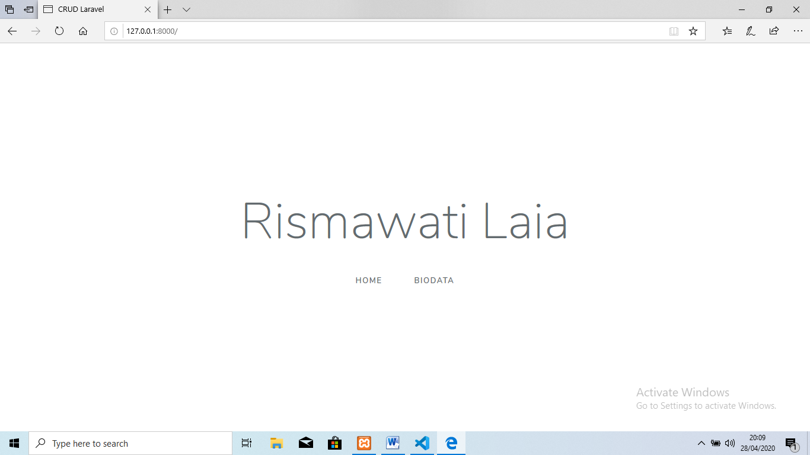

8. Tampilan program biodata

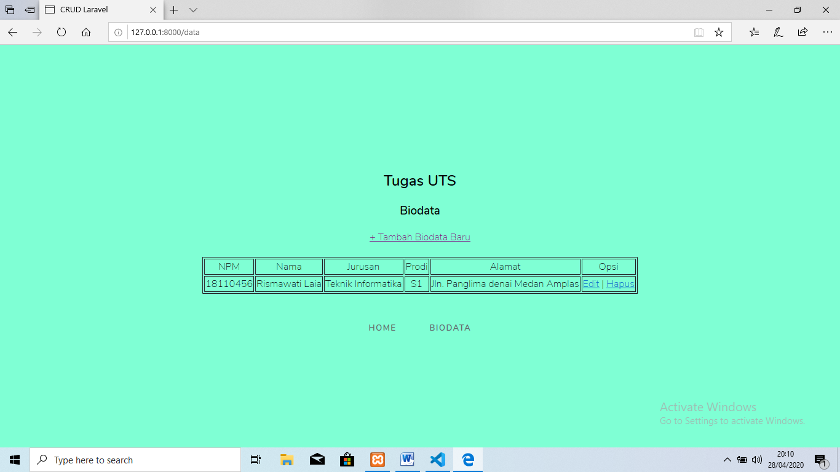

9. Tampilan form tambah data

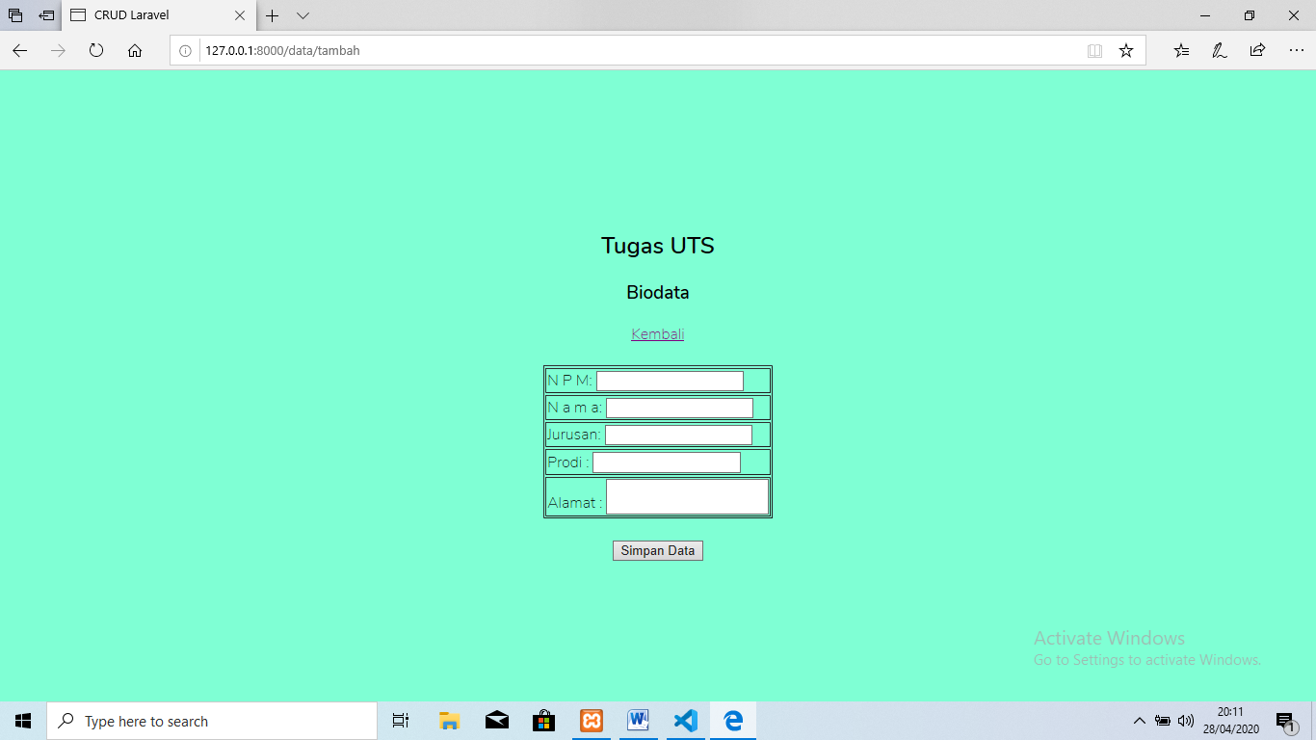

10. Tampilan edit data

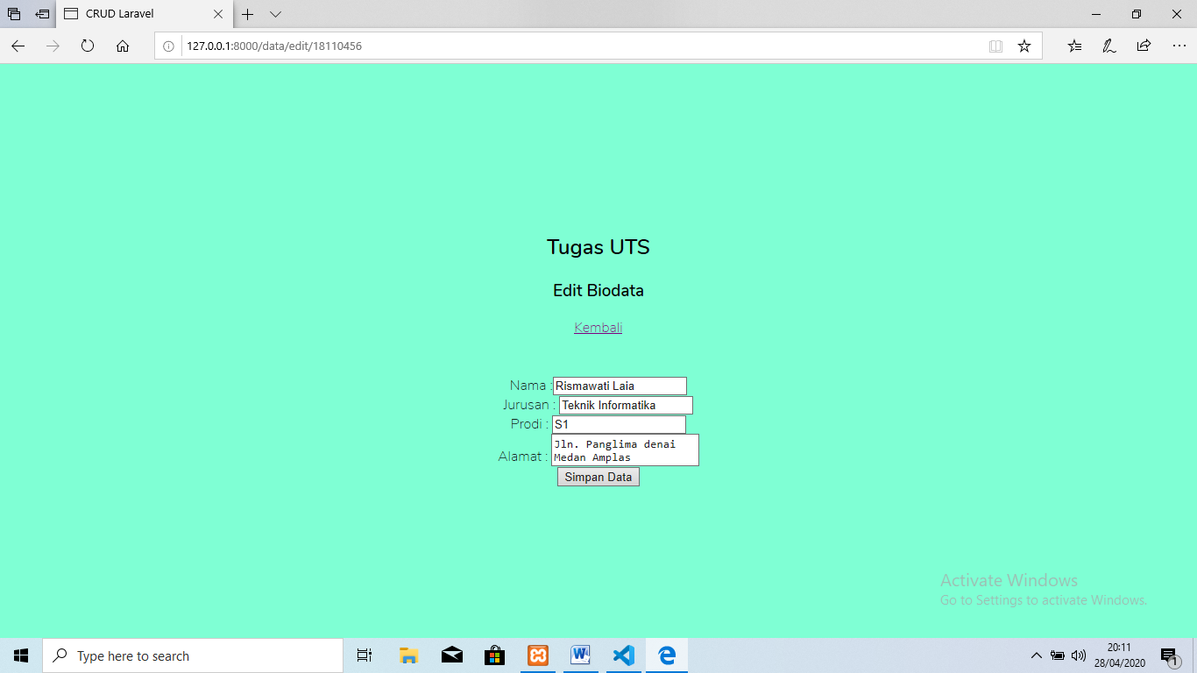

11. Link Github :